**Year 4**

Week beginning Monday 3rd November

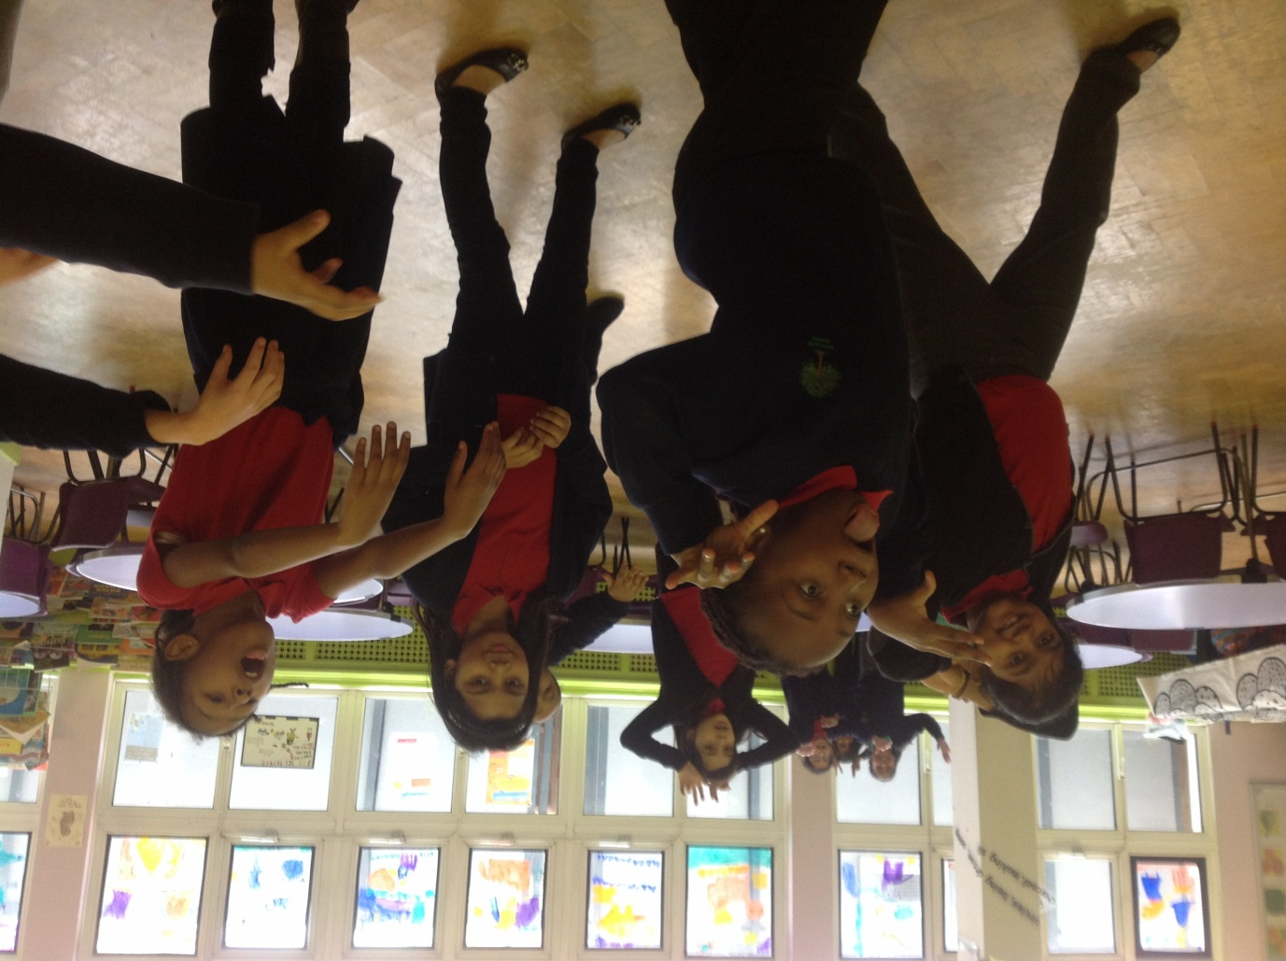

This week, we started working with our school song writer. We began our work by thinking about stories we liked and we used drama to show different types of characters.